# Hardware

This will describe the process of ordering the items and wiring them together.

Links to the parts contain Banggood’s affilate metadata.

## Parts

Wemos NodeMCU with an OLED display The brain of this project. Provides processing, connectivity and instant data feed on the display. [Buy Wemos with an OLED](https://www.banggood.com/Wemos-Nodemcu-Wifi-For-Arduino-And-NodeMCU-ESP8266-0_96-Inch-OLED-Board-p-1154759.html?cur_warehouse=CN&p=X314102609367201509L&custlinkid=113882)

Nova SDS011 The main sensor used to measure PM2.5 and PM10 [Buy SDS011](https://www.banggood.com/Nova-PM-Sensor-SDS011-High-Precision-Laser-PM2_5-Air-Quality-Detection-Sensor-Module-p-1144246.html?p=X314102609367201509L&custlinkid=113881)

DHT22 (AM2302) Additional sensor to measure humidity and temperature [Buy DHT22](https://www.banggood.com/AM2302-DHT22-Temperature-And-Humidity-Sensor-Module-For-Arduino-SCM-p-937403.html?p=X314102609367201509L&custlinkid=113883)

4x longer M3x20 screws to hold the main case plates together [Buy M3x20](https://www.banggood.com/Suleve-M3CH9-50Pcs-M3-Carbon-Steel-Hex-Socket-Cap-Head-Screws-Bolts-4-20mm-Optional-Length-p-1217022.html?rmmds=search&ID=513285&cur_warehouse=CN&p=X314102609367201509L&custlinkid=666336)

4x shorter M3x8 screws to mount the Wemos board [Buy M3x8](https://www.banggood.com/Suleve-M3CH9-50Pcs-M3-Carbon-Steel-Hex-Socket-Cap-Head-Screws-Bolts-4-20mm-Optional-Length-p-1217022.html?rmmds=search&ID=513285&cur_warehouse=CN&p=X314102609367201509L&custlinkid=666336)

## Assembly

Use the diagram to connect all the parts

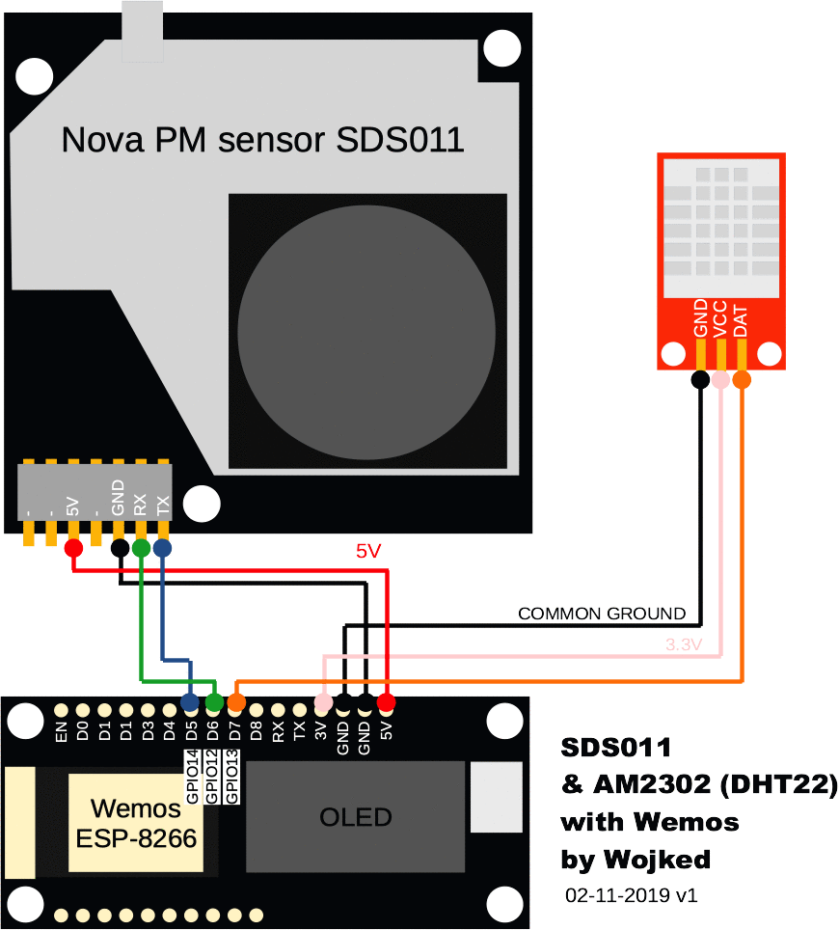

SDS011 has two data wires (TX,RX) to be connected to data pins on the Wemos board. Let’s use D5 (GPIO14) and D6 (GPIO12). If you happen to connect them differently, you will be able to configure it later on in firmware. It requires 5V and GND.

DHT22 board has only 1 data wire to be connected to one of the data pins on the Wemos board. Let’s use D7 (GPIO13) but you might use any one that is free. It might be powered by 3.3V and GND.

OLED - you do not have to do anything as it is already connected to the board: SDA to D1 (GPIO-5) and SCL to D2 (GPIO-4).

It should look more or less like this, once you are d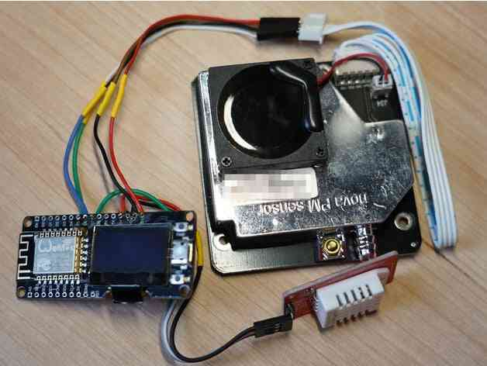one

Now put everything into the 3D printed 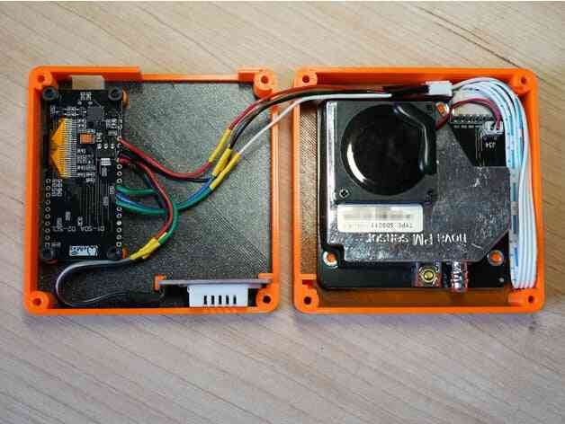case.

## Firmware

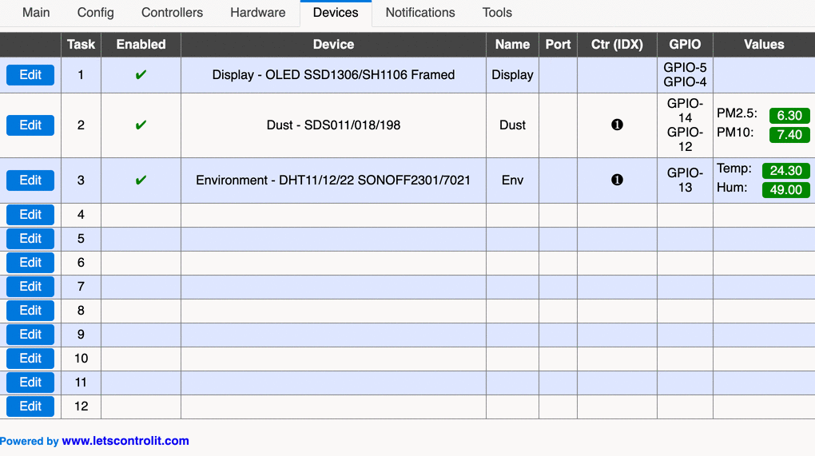

We are going to use [ESP Easy](https://github.com/letscontrolit/ESPEasy) developed by [Let’s control it Team](https://www.letscontrolit.com/).

## I2C interface

Once the firmware is loaded and you are connected to the admin panel visit Hardware tab and configure I2C interface SDA - GPIO-5 (D1) and SDA - GPIO-4 (D2). This will allow OLED to work

## Devices

Now visit Devices tab. We are going to add 3 devices:

### OLED

Select the OLED SSD1306/SH1106 Framed as the device.

I suggest to call it Display.

Please use SSD1306 controller and the 0x3C(60) - default I2C address.

Choose the correct orientation of the screen (Normal in my case).

There will be 3 Lines per frame.

We are now going to define those “lines” using these templates:

PM2.5:[Dust#PM2.5]

PM10: [Dust#PM10]

[Env#Hum]% [Env#Temp]C

### SDS011

Select the Dust - SDS011/018/198 as the device.

I suggest to call it Dust (it is referred this way in the OLED).

TX is connected to GPIO-14 (D5) in our case.

RX is connected to GPIO-12 (D6) in our case.

I suggest to set sleep time to 20 minutes.

Expose the values that are referred in our OLED config:

PM2.5 with 2 decimals

PM10 with 2 decimals

### DHT22 (AMS2302)

Select the Environment - DHT11/12/22 SONOFF2301/7021 as the device.

I suggest to call it Env (it is referred this way in the OLED).

It is connected to GPIO-13 (D7) in our case and it is a DHT22 type.

Set the interval to 300 seconds.

Expose values that are referred in our OLED config:

Temp with 2 decimals

Hum with 2 decimals

Working device

After these steps, your device should be fully functional!

## Integration with smart home

There are multiple ways of integrating this device into your home automation setup. I am going to describe the most convinient one- using MQTT and [Home Assistant](https://www.home-assistant.io/) - my preferred home automation solution.

Unit name

Visit the Config tab. Set the Unit Name so it would be easier to refer the device, especially if you plan to add several units, I am going to use ESP_UNIT in this documentation.

Publish data to MQTT

Visit Controllers tab.

Select a MQTT protocol, I suggest OpenHAB MQTT that works with Home Assistant.

You need to provide the address and port of your MQTT server as well as the credentials (username and password).

Subscribe for topics home/%sysname%/# and publish to home/%sysname%/%tskname%/%valname%.

Add new sensors to HA

Now add these MQTT sensors to your config in Home Assistant (remember to replace ESP with the real unit name):

- platform: mqtt

state_topic: 'home/ESP_UNIT/Env/Hum'

unit_of_measurement: '%'

name: 'ESP Humidity'

- platform: mqtt

state_topic: 'home/ESP_UNIT/Env/Temp'

unit_of_measurement: '°C'

name: 'ESP Temperature'

- platform: mqtt

state_topic: 'home/ESP_UNIT/Dust/PM2.5'

unit_of_measurement: 'AQI'

name: 'ESP PM25'

- platform: mqtt

state_topic: 'home/ESP_UNIT/Dust/PM10'

unit_of_measurement: 'AQI'

name: 'ESP PM10'

After you restart the Home Assistant, you should be able to see readouts from your 4 freshly added sensors.